According to Intelli, the Hungary ophthalmic devices market was valued at USD 56.88 million in 2024 and is expected to reach USD 77.26 million by 2032, growing at a CAGR of 4.29% from 2024 to 2032.

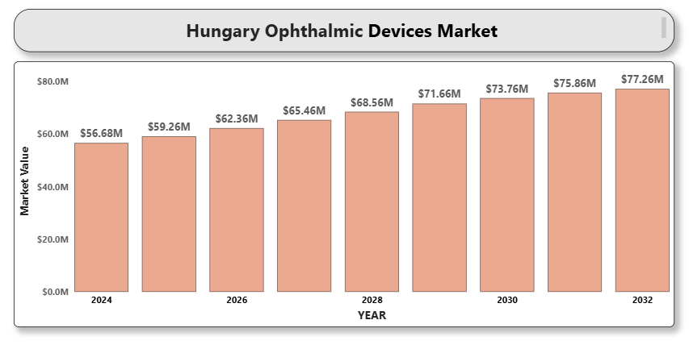

Hungary's ophthalmic devices market is experiencing steady growth due to increasing incidences of eye disorders such as cataracts, glaucoma, and diabetic retinopathy. The rise in the aging population, higher screen time contributing to vision problems, and improvements in diagnostic and surgical technologies are key factors driving demand. Furthermore, Hungary's participation in EU healthcare programs and increasing investments in public and private ophthalmic infrastructure are supporting market expansion.

**Hungary Ophthalmic Devices Market Definition**

Ophthalmic devices refer to equipment used for vision correction, diagnosis, and surgical treatment of various eye-related conditions. These include optical devices like contact lenses and spectacles, diagnostic instruments such as ophthalmoscopes and OCT scanners, and surgical devices including phacoemulsification systems and intraocular lenses.

**Hungary Ophthalmic Devices Market Overview**

The Hungarian market is benefiting from heightened awareness about eye health, expanding access to vision care services, and an increase in cataract and LASIK surgeries. There is a growing preference for advanced ophthalmic solutions that offer better precision, safety, and post-operative outcomes. However, challenges such as limited reimbursement for premium procedures and high device costs could restrain market growth.

**Hungary Ophthalmic Devices Market Segmentation Analysis Market Segmentation by Product Type:**

**• Diagnostic Devices**

o Optical Coherence Tomography (OCT)

o Fundus Cameras

o Ophthalmoscopes

o Autorefractors and Keratometers

o Tonometers

**• Surgical Devices**

o Cataract Surgery Devices

o Glaucoma Surgery Devices

o Vitreoretinal Surgery Devices

o Refractive Surgery Devices

**• Vision Care Devices**

o Spectacles

o Contact Lenses

Vision care devices dominate the market due to increasing cases of refractive errors and a rising population using vision correction aids.

**Market Segmentation by Application:**

• Cataract

• Glaucoma

• Refractive Error

• Age-related Macular Degeneration

• Diabetic Retinopathy

• Others

Cataract and refractive error applications account for a significant market share due to the high prevalence and the increasing number of corrective surgeries performed annually.

**Market Segmentation by End User:**

• Hospitals

• Ophthalmic Clinics

• Ambulatory Surgical Centers

• Others

Hospitals lead the market owing to the availability of advanced surgical setups and comprehensive diagnostic facilities.

**Market Segmentation by Region:**

• Central Hungary

• Transdanubia

• Northern Hungary

Central Hungary dominates due to the presence of top-tier hospitals, research institutions, and a higher concentration of practicing ophthalmologists.

**Key Players**

Major companies operating in Hungary’s ophthalmic devices market include Alcon Inc., Johnson & Johnson Vision Care, Inc., Carl Zeiss Meditec AG, Bausch + Lomb Incorporated, Topcon Corporation, NIDEK Co., Ltd., Ziemer Ophthalmic Systems AG, EssilorLuxottica SA, Haag-Streit Group, and Hoya Corporation.

**Key Developments**

• In 2024, Alcon launched a next-gen phacoemulsification system in Hungary aimed at enhancing cataract surgery outcomes. • Bausch + Lomb announced the expansion of its vision care division into Central Europe, including Hungary, in Q1 2024.

* In 2024 NIDEK introduced the RS-1 Glauvas Optical Coherence Tomography. The RS-1 Glauvas is a new OCT system with up to 250kHz scan speed, high-quality wide and deep area imaging, excellent operability, and deep learning-based analysis.

**Market Attractiveness**

Hungary is an attractive ophthalmic devices market due to increasing surgical volume, EU healthcare collaboration, and access to modern eye care technologies. The presence of skilled healthcare professionals and supportive healthcare infrastructure enhance the market's growth potential.

**Porter's Five Forces**

• Threat of New Entrants: Moderate – Barriers include regulatory approvals and high capital requirements.

• Bargaining Power of Suppliers: Moderate – Specialized components reduce supplier options, but global suppliers provide flexibility.

• Bargaining Power of Buyers: High – Hospitals and clinics demand cost-efficient and advanced devices.

• Threat of Substitutes: Low – Surgical and diagnostic precision is hard to replicate with alternatives.

• Industry Rivalry: High – Several global and regional players compete on technology and pricing.

**TABLE OF CONTENTS**

1. **INTRODUCTION OF HUNGARY OPHTHALMIC DEVICES MARKET**

1.1 Overview of the Market

1.2 Scope of Report

1.3 Assumptions

1. **EXECUTIVE SUMMARY**
2. **RESEARCH METHODOLOGY**

3.1 Data Mining

3.2 Validation

3.3 Primary Interviews

3.4 List of Data Sources

1. **HUNGARY OPHTHALMIC DEVICES MARKET OUTLOOK**

4.1 Overview

4.2 Market Dynamics

4.2.1 Drivers

4.2.2 Restraints

4.2.3 Opportunities

4.2.4 Trends

4.3 Porter's Five Force Model

4.4 Value Chain Analysis

1. **HUNGARY OPHTHALMIC DEVICES MARKET, BY PRODUCT TYPE**

5.1 Diagnostic Devices

5.2 Surgical Devices

5.3 Vision Care Devices

1. **HUNGARY OPHTHALMIC DEVICES MARKET, BY APPLICATION**

6.1 Cataract

6.2 Glaucoma

6.3 Refractive Error

6.4 Age-related Macular Degeneration

6.5 Diabetic Retinopathy

6.6 Others

1. **HUNGARY OPHTHALMIC DEVICES MARKET, BY END USER**

7.1 Hospitals

7.2 Ophthalmic Clinics

7.3 Ambulatory Surgical Centers

7.4 Others

1. **HUNGARY OPHTHALMIC DEVICES MARKET, BY REGION**

8.1 Central Hungary

8.2 Transdanubia

8.3 Northern Hungary

1. **HUNGARY OPHTHALMIC DEVICES MARKET COMPETITIVE LANDSCAPE**

9.1 Overview

9.2 Company Market Ranking

9.3 Key Development Strategies

1. **COMPANY PROFILES**

**10.1 Alcon Inc.**

10.1.1 Overview

10.1.2 Financial Performance

10.1.3 Product Outlook

10.1.4 Key Developments

**10.2 Johnson & Johnson Vision Care, Inc.**

10.2.1 Overview

10.2.2 Financial Performance

10.2.3 Product Outlook

10.2.4 Key Developments

**10.3 Carl Zeiss Meditec AG**

10.3.1 Overview

10.3.2 Financial Performance

10.3.3 Product Outlook

10.3.4 Key Developments

**10.4 Bausch + Lomb Incorporated**

10.4.1 Overview

10.4.2 Financial Performance

10.4.3 Product Outlook

10.4.4 Key Developments

**10.5 Topcon Corporation**

10.5.1 Overview

10.5.2 Financial Performance

10.5.3 Product Outlook

10.5.4 Key Developments

**10.6 NIDEK Co., Ltd.**

10.6.1 Overview

10.6.2 Financial Performance

10.6.3 Product Outlook

10.6.4 Key Developments

**10.7 Ziemer Ophthalmic Systems AG**

10.7.1 Overview

10.7.2 Financial Performance

10.7.3 Product Outlook

10.7.4 Key Developments

**10.8 EssilorLuxottica SA**

10.8.1 Overview

10.8.2 Financial Performance

10.8.3 Product Outlook

10.8.4 Key Developments

**10.9 Haag-Streit Group**

10.9.1 Overview

10.9.2 Financial Performance

10.9.3 Product Outlook

10.9.4 Key Developments

**10.10 Hoya Corporation**

10.10.1 Overview

10.10.2 Financial Performance

10.10.3 Product Outlook

10.10.4 Key Developments

1. **A close-up of hands holding a tablet and a pen

   Description automatically generatedKEY DEVELOPMENTS**

11.1 Product Launches/Developments

11.2 Mergers and Acquisitions

11.3 Business Expansions

11.4 Partnerships and Collaborations

1. **APPENDIX**

12.1 Related Research